We use github as our version control tool. Some pictures can prove our effect.

1. This is web frond-end design period version control.

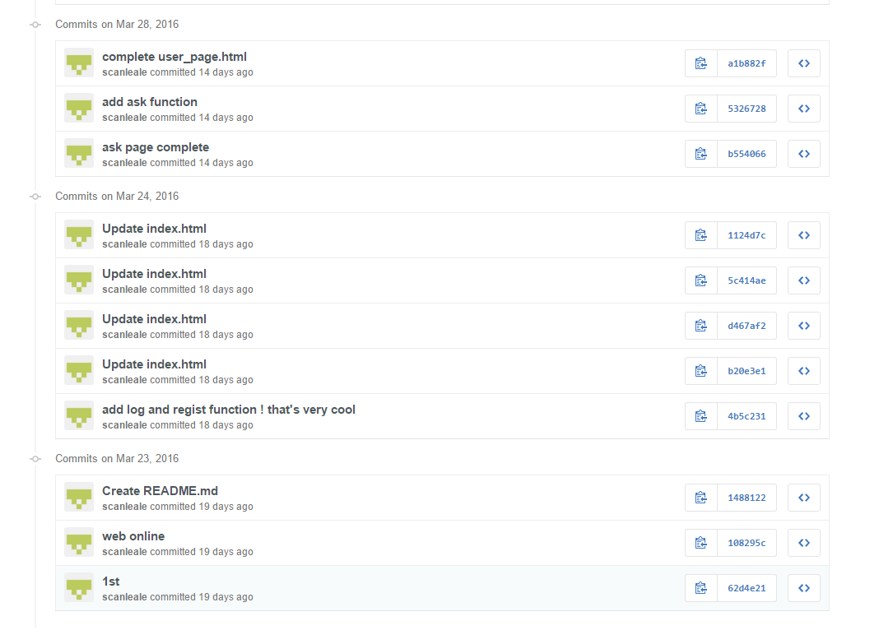

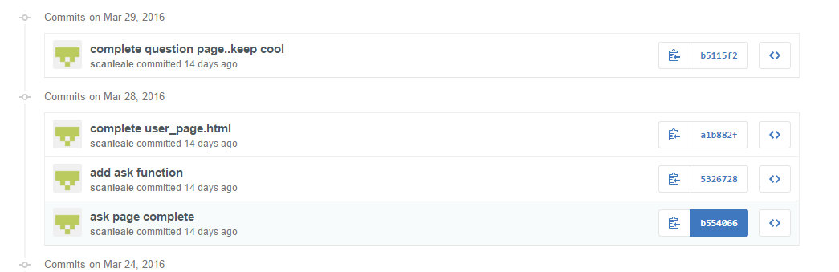

1. This is our background program version control.

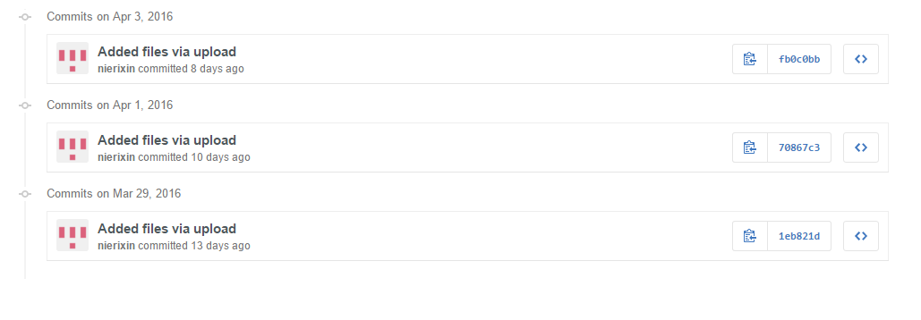

We upload this code as a war file, so we can deploy it on server quickly.